**Assignment 1**

**Powerbi report view**

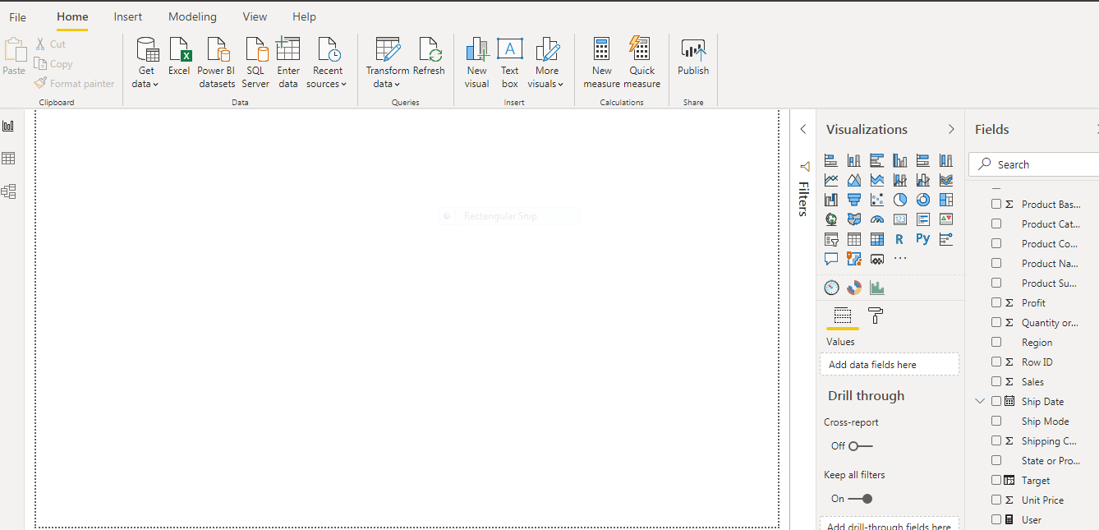

**Powerbi Data View**

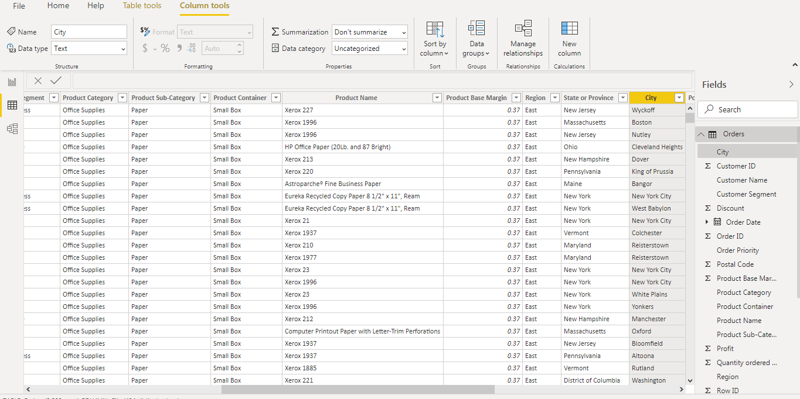

**Powerbi Model View**

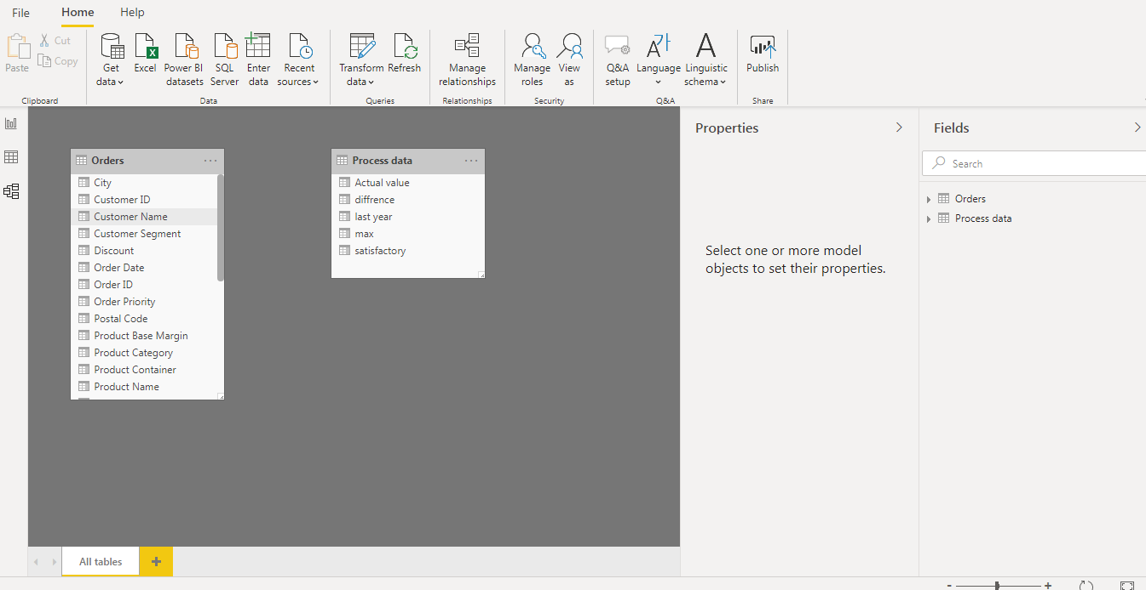

**Power Query Editer**

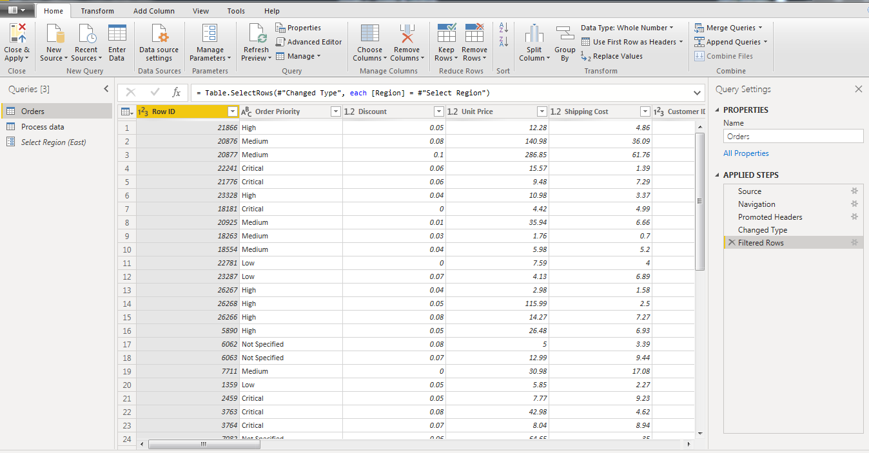

**Advance Editer**

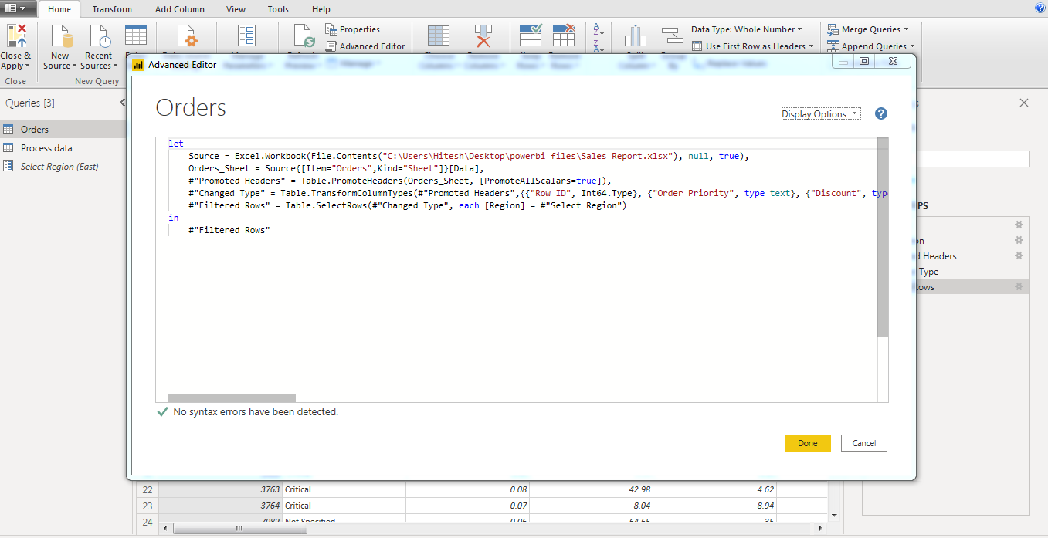

**Powerbi Desktop**

Power BI Desktop is the free version of Power BI that you can install on your local computer as a program, and acts as a companion desktop application to the full version of Power BI. If you need to consolidate your data sources, create your own reports and conduct your own analysis or test it’s capabilities, it’s the perfect version to start with for all skill levels - whether you’re non-IT and want to make your reports more interactive, or analysts seeking richer detail, it's one of the best business analytics tools to use.

**Powerbi Pro**

Power BI Pro is the full version of Power BI, complete with the ability to use Power BI for both building dashboards and reports and unlimited viewing, sharing and consumption of your created reports (and reports shared by others) - the latter not possible with Power BI Desktop.

Cost: The Pro plan costs $9.99/user/month. It includes data collaboration, data governance, building dashboards with a 360-degree real-time view and the ability to publish reports anywhere. Users can try it a free trial for 60 days before purchasing the subscription.

**Powerbi Premium**

Power BI Premium is the most expensive tier of Power BI currently available and very distinct from the other two versions available on the market.

On top of the features and functionality standard to all versions of the service, users of Power BI Premium get:

* Increased data capacity limits and maximum performance
* Access to one API surface
* Ability to embed Power BI visuals into apps (PowerApps, SharePoint, Teams, etc)
* Larger storage sizes for extended deployments
* Geo distribution, higher refresh rates, isolation, pin to memory, read-only replicas
* Power BI Report Server

Power BI Premium differs from the free version and Power BI pro in its licensing model, which only suits a specific size and type of organisation and business scenario. You can purchase Premium in a range of capacity sizes that offer different numbers of memory and virtual cores that can scale as your data analysis requirements change.

With Power BI Premium, you are licensing capacity for your datasets, dashboards and reports, not just licensing all users of that content. In other words, you’re not buying individual licenses, you’re buying them in bulk to allow a large number of your users to use Power BI to view reports. All of your content is stored in Premium and can then be viewed by as many users in your organisation as you want, without additional per-user costs.

**Power BI Premium Cost**

The Premium plan starts at $4,995 a month per dedicated cloud compute and storage resource. This does not include the cost of licensing for individual Pro and Free licenses required for each user in your organisation.